**Pokemon Battle Win Rate Prediction**

DATA1030 Midterm Report

Taemin Huh

[*https://github.com/taemin-huh/data1030-project/*](https://github.com/taemin-huh/data1030-project/)

**1 Introduction**

The Pokémon franchise, originating from a video game developed by Game Freak and published by Nintendo in 1996, is one of the highest grossing media franchises of all time. The game series sold 440 million copies worldwide, and was adapted into various media forms such as TV series, movies, comics, and trading cards.1 Competitive Pokémon battling became an established discipline with large-scale tournaments, circuits, cash prizes and scholarships, and the next Pokémon to include in one’s team has often been a popular discussion among communities.

Pokémon battles are turn-based, and each Pokémon can perform a move during its turn with the goal of reducing the opponent’s Health Points (HP) to 0. Attack, Defense, Special Attack and Special Defense stats are involved in damage calculation, while Speed generally determines which Pokémon attacks first each turn. There are 18 different elemental types that interact with one another, and all Pokémons have at least one and at most two types.

This project attempts to utilize machine learning tools to predict the win rate (0-1) of a given Pokémon. To solve this regression problem, it uses two datasets published by the Weedle’s Cave project on Kaggle2: *Pokémon* and *Combat*. *Pokémon* dataset contains 12 features of 800 Pokémons collected from the actual game, including their unique ID, name, type 1, type 2, six base stats (HP, Attack, Defense, Special Attack, Special Defense and Speed), game generation (1st-6th), and whether they are Legendary. *Combat* dataset contains datapoints of 50,000 Pokémon battles generated through a custom algorithm across three columns: ID’s of (1) Pokémons that attacked first, (2) those that attacked after, and (3) the winners. It was further feature engineered for this project by counting the total number of wins and total number of battles for each Pokémon, then dividing the two (not included as features) to arrive at the target variable: win rate.

There are several public projects based on these datasets. J. Bouchet trained a model to predict battle outcomes based on stat differences of winning and losing Pokémons, and scored an average of 91% with 5-fold cross-validation.3 V. Liao also created a model to predict battle outcomes, and demonstrated a peak accuracy of 96% using the random forest model.4

**2 Exploratory Data Analysis**

As shown below in Figure 1, the target variable win rate is rather evenly and symmetrically distributed with a mean value of 0.50 and median value of 0.49.

**Figure 1.** Histogram showing distribution of win rate.

As illustrated by Figure 2, Speed is the feature with the strongest correlation to win rate with a 0.94 Pearson correlation coefficient, contrary to the initial expectation that Attack and Special Attack would be. This makes sense, as being able to consistently hit first each turn often translates to an extra turn before the opponent faints when exchanging blows in order, or a single-hit KO during the first turn of the battle.

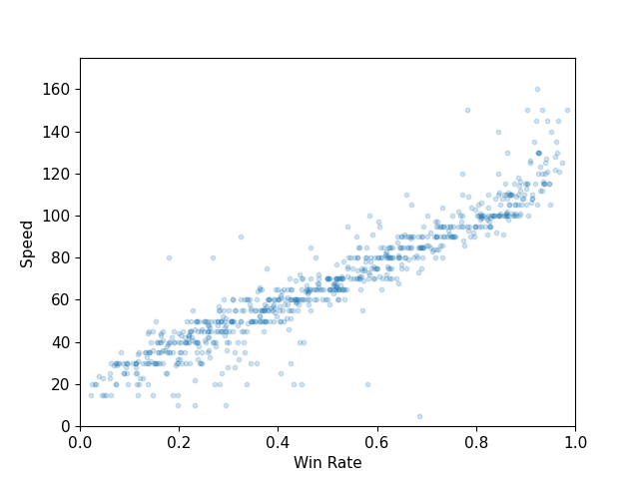

**Figure 2.** Scatter plot showing speed stat against win rate.

As shown in Figure 3, there seems to be no meaningful power inflation of Pokémons over the release of newer games, with the win rates evenly distributed across the six generations. This illustrates that the series have maintained the balance of Pokémons relatively well since its first game.

**Figure 3.** Box plot showing win rate of Pokémons from each generation.

Lastly, Figure 4 shows that Legendary Pokémons are more likely to show higher win rate (clustered in range above 0.5) than non-Legendary ones. This could be attributable to the fact that they are a unique class of Pokémons that represent each game title and tend to have above-average base stats.Chart

**Figure 4.** Violin plot comparing win rate of Legendary vs.  
non-Legendary Pokémons.

**3 Preprocessing**

A basic split of 60%/20%/20% was used across train/test/validation sets, as the data is independently and identically distributed without any group structure or time-series property. Given the large number of datapoints (800 in *Pokémon*, 50,000 in *Combat*), k-fold split was not deployed as it is more computationally heavy than basic split while achieving similar results when datasets are sufficiently large.

OneHotEncoder was used for the four categorical features (type 1, type 2, generation and Legendary) as none of these are ordinal or have a clear hierarchy. Type 1 is encoded into 18 features since 18 types exist, and type 2 into 19 features since not having a secondary type should be regarded as a feature on its own. Generation is encoded into six features given there are six generations, and Legendary into two given it is a Boolean.

MinMaxScaler was used for all other continuous features (HP, Attack, Defense, Special Attack, Special Defense, Speed) as the six base stats have a hard range limit of 0 to 255 – 255 is the maximum value representable by an eight-digit binary number, which was the hardware limitation of the first Pokémon games and a convention kept until today. As a result, there are a total of 51 features after preprocessing: original 14 from X_train, less unique ID and name, less total win and battle count created (directly involved in calculating win rate), plus the extra 17+18+5+1 from OneHotEncoder.

The project aims to further explore correlations between first and second attack Pokémon columns from *Combat* dataset with win rate. Although it is possible for a slower Pokémon to strike first through in-game mechanics such as priority moves, hold items, switch-ins and environment effects (with caveats of their own), there are no details of these mechanics specified in the datasets – however, it is expected that having a higher Speed stat would still substantially affect win rate even if a Pokémon did not hit first during the first turn of the game, as faster Pokémons are still likely to move first more consistently throughout the rest of the game.

**4 References**

1 The Pokémon Company. (2022, March). Pokémon in Figures. Retrieved October 21, 2022, from <https://corporate.pokemon.co.jp/en/aboutus/figures/>

2 Weedle's Cave. (2017). Pokemon- Weedle's Cave. Retrieved October 21, 2022, from <https://www.kaggle.com/datasets/terminus7/pokemon-challenge>

3 Bouchet, J. (2017, September 27). Pokemon Battles. Retrieved October 21, 2022, from <https://www.kaggle.com/code/jonathanbouchet/pokemon-battles>

4 Liao, V. (2017, December 18). Visualizing Data and Predicting Pokemon Fights. Retrieved October 21, 2022, from <https://www.kaggle.com/code/vforvince1/visualizing-data-and-predicting-pokemon-fights/notebook>